BEST HCM Implementation

Payroll Processing in HCM
Updated: January 31, 2024


Table of Contents
- A Day in the Life of Payroll Processing
- HCM Payroll Process Components
- Reading the HCM Payroll Calendar
- Time and Leave Entry in HCM
- HCM Preliminary Payrolls and Payroll Processing and Reports

A Day in the Life of Payroll













A Day in the Life of Payroll Processing
1. Look at your
infoAdvantage Reports
2. Adjustments for a Prior Closed Pay Period.
This is entered in the current pay period so that is can be picked up in the retroactive cycle
DO NOT hold prior pay period adjustments. Create the TADJ’s when you get them to make sure they
are picked up in the retroactive cycle
Deductions Management
(DEDM) Activity Folder
Changes to CalSTRS or CalPERS Retirement Enrollments
Employee Pension
Profile (PENS)
A Retroactive Trigger will be created
HCM InfoAdvantage
Pending Pay Report
(HCM-PAYR-0087
Pending Payments)
Time Report (OHCM-
TIME-0205 Time Report)
Pending Deductions
(HCM-DEDS-0224
Pending Deductions)
Payroll Management (PAYM) Activity Folder – Timesheet Adjustment (TADJ) document

Entering information from late timesheets or updated timesheets.
Examples include additional hours, sick usage adjustments or vacation usage adjustments

Enter Flat Dollar
payments

Workers Compensation
Adjustments

Note: Changes to Account Strings (LDPR codes) for prior closed pay periods MUST be done in FIN
Benefits Administration (BA) Activity Folder
Changes to Benefit Enrollments Benefit Enrollment (ENRL)
A Retroactive Trigger
will be created

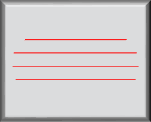

Note: Payroll Cycle begins the day after the previous cycle closes in production. This is not the issue date.




A Day in the Life of Payroll Processing
Timesheet Group Roster (TSG)
Adding or Deleting Employees from Timesheet Group Roster (TSG)
Only used for Group
Timesheets (TIMEG)
Overpayments
Creating a one-time payout that is either lump sum or hours based. For example, vacation payouts.
Timesheet Adjustment
(TADJ)







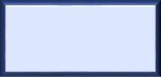





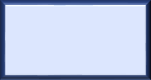
3. Enter Information for a Current Pay Period

Time and Leave (ATLM) Activity Folder

Deduction Management (DEDM) Activity Folder

Benefits Administration (BA) Activity Folder
Exception Entries for Exception Paid Employee
Exceptions for non-
Regular time Group Timesheet (TIMEG), Timesheet Adjustment (TADJ) or Timesheet Adjustment
Interface (TADI)
Positive Entries for Positive Paid Employee
ALL Time and Leave Usage activity Group Timesheet (TIMEG), Timesheet
Adjustment (TADJ) or Timesheet Adjustment Interface (TADI)
Changes to employee
tax information Tax Parameters (TAX)
Changes to employee direct deposit information
Net Pay Distribution
(NPD)

Changes to an employee's voluntary deductions Miscellaneous Deductions (MISC)
Changes to an employee’s CalSTRS or CalPERS enrollments Employee Pension Profile (PENS)
Starting an employee’s
Garnishment Family Course/Arrears/
Bankruptcy (GARN) Tax Levy (LEVY) Garnishments (GARN)
Creating a One-Time Deduction. For example, collecting for an overpayment or adjusting premium for benefit deductions One-Time Deductions (OTDED)

Change to Benefit Enrollments Benefit Enrollment (ENRL)

HCM Payroll Process Components


















Regular Payroll Process in HCM
Preliminary Payroll
Regular Payroll Production
Bank File & Check Generation
Sent out after Payroll completes, processed by bank and/or printed & distributed
Issue Date
Payroll Accounting
Vendor Payments
The check date (funds available)
Retirement Reporting

Actual Payroll Production Date (usually 3 days before check date)




Time to Gross
Processing of Time Documents

A preview of what payroll will look like

Time Data Entry Options
Time data must get into the BEST Advantage HCM system in some method
Time to Gross calculations are required to start payroll processing
Time from 3rd Party Timekeeping System
Interface Functionality (TADI)

From third party time entry systems (e.g. NovaTime, Kronos, etc.)
Time Entry in HCM for Positive Paid and
Exception Paid Employee Assignments
Group Timesheets (TIMEG)
Timesheet Adjustments (TADJ)
Timekeepers from paper timesheets for a group of employees / assignments all at once
Corrections to timesheets or exceptions entered by timekeepers

Exception Paid Employees
Time to Gross Process
(TTG)

Exception paid employees are automatically paid regular wages based on base rates

Preliminary Payroll Discussions to Date


8-10 days prior to Production date
Preliminary Payroll 1
Validate the correct exception paid employees are included (make ESMT changes if necessary)
Enter TIMEG for positive and exception paid employees

2 days prior to Production date
Validate all time data has been entered
Preliminary Payroll 2
Validate all employees have the correct data. Make adjustments/changes using Timesheet Adjustments (TADJ), Employee Status Maintenance (ESMT) and/or One-Time Deduction (OTDED) documents

1 day prior to Production date
Validate all employees have the correct data. Make adjustments/changes using Timesheet Adjustments (TADJ), Employee Status Maintenance (ESMT) and/or One-Time Deduction (OTDED) documents
Preliminary Payroll 3
No further chance to validate except final payroll reports


Time Report goes away.
Preliminary Payroll is similar to current Verification

Errors found must be fixed in the HCM application where they originate

If an employee is Positive Paid, a TIMEG or TADJ must be entered and finalized, or the system will not produce any pay. As a District you can select a date as to when timesheets must be received.


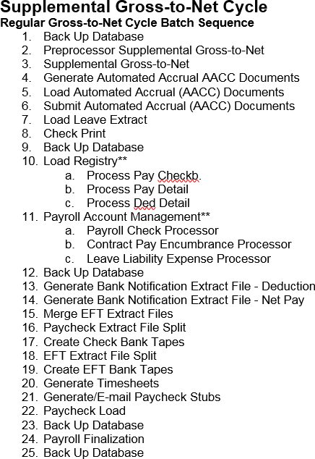
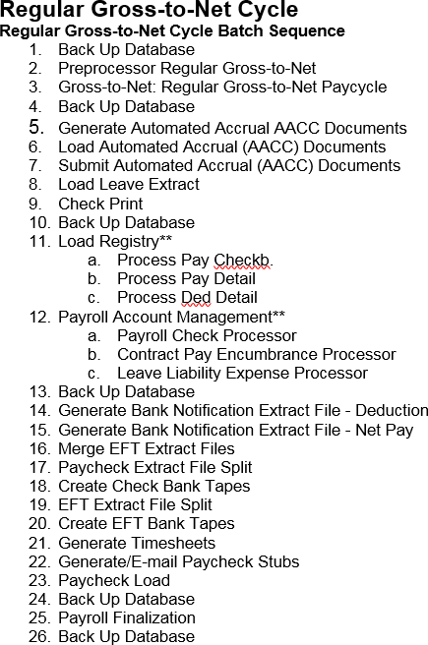
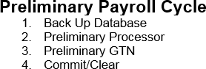
Preliminary vs Supplemental vs Regular
Supplemental will be run weekly to handle the true reason for a supplemental…Separate a unique payroll run such as mass retro or bonuses

Regular Payroll

- Once the third Preliminary run is completed the next night Regular Payroll Cycle will begin. Payroll numbers will remain the same with the following exceptions:
  - H1 becomes E4
  - V2 becomes C5

Pay  Cycle | Earned Start  Date | Earned End  Date | Long Description | Short  Description | Check Date
C1 | 1/1/2018 | 1/31/2018 | Monthly 1st WD | MTHLY 1st WD | 2/1/2018
C2 | 1/1/2018 | 1/31/2018 | Monthly Last WD | MTHLY LAST WD | 1/31/2018
C3 | 1/1/2018 | 1/31/2018 | Monthly 10th | MTHLY 10th | 2/10/2018
C5 | 1/1/2018 | 1/31/2018 | Monthly 5th | MTHLY 5th | 2/5/2018
E1 | 1/1/2018 | 1/15/2018 | Semi-Monthly 5th and 20th | SEMI 5th/20th | 1/20/2018
 | 1/16/2018 | 1/31/2018 |  |  | 2/05/2018
E4 | 1/1/2018 | 1/15/2018 | Semi-Monthly 10th and 25th  TECHNOLOGY SERVICES | SEMI 10th/25th | 1/25/2018
 | 1/16/2018 | 1/31/2018 | Semi-Monthly 10th and 25th  TECHNOLOGY SERVICES |  | 2/10/2108

Reading the HCM Payroll Calendar

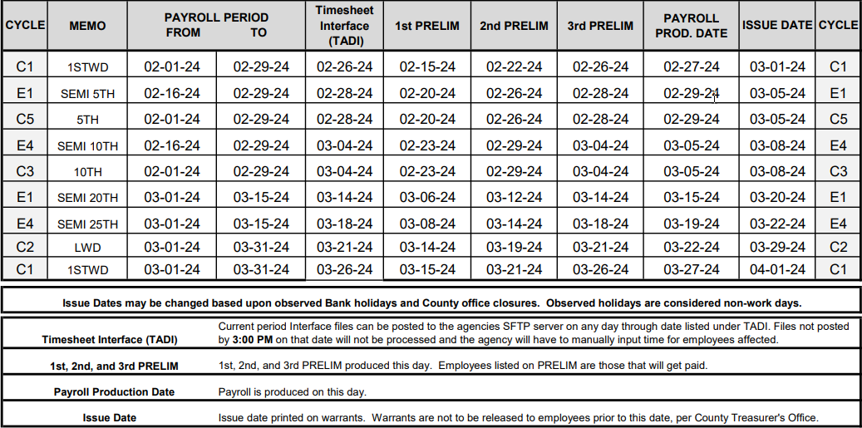
HCM Payroll Calendar
1

2 | 3 | 4 | 5 | 6

- The HCM Payroll Calendars are available on the Customer Resource Center
- Supplemental Payroll is twice per week or less with holidays. Check the schedule

HCM Payroll Calendar
1

2 | 3 | 4 | 5 | 6

  - Cycle identifies the HCM Payroll Cycles. The following HRS Payroll Cycles are rolled up into other payroll cycles in HCM:
    - H1 becomes E4
    - V2 becomes C5
  - The Payroll Period Start and End Dates

HCM Payroll Calendar
1

2 | 3 | 4 | 5 | 6

  - Lists the latest date for loading the Timesheet Interface (TADI) file in HCM. This is used by Districts that have 3rd part Time and Leave systems.
  - Identifies the dates for the three Preliminary Payrolls
  - Identifies the Payroll Production Date

HCM Payroll Calendar

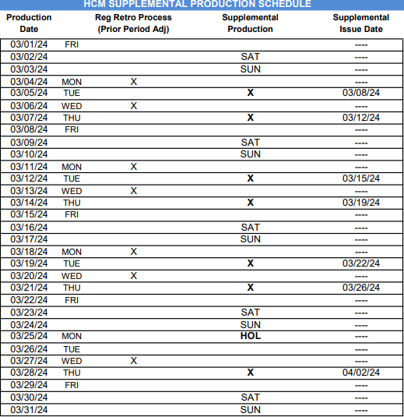
    - Regular Retro Process:
      - Run Monday and Wednesday except for Holidays
      - Create triggers that will generate pending payment and pending deduction documents
      - These pending payments and pending deductions will be processed in the employee’s next payroll period
      - To process pending payments and pending deductions, they must be updated to designate to they be processed on the next Supplemental Payroll. (See Slide 5)
    - Supplemental Production
      - Run Tuesday and Wednesday except for
Holidays
      - Can by Direct Deposited if the employee has a Net Pay Distribution
    - Supplemental Issue Date
      - Identifies the specific issue date for the Supplemental Payrolls

Time and Leave Entry in HCM


Time Entry Options in HCM

What does your District do?






















Certificated Employees

Classified Employees

Certificated Substitutes

Board Members
Other Employee Types
Timesheet Groups
(TIMEG)
Entering Time information using Timesheet Group Rosters (=HRS Time Report Location)
Timesheet Adjustment (TADJ) UPDOC
Time and Leave Usage information from a 3rd Party System using an UPDOC
Timesheet Interface
Time and Leave Usage information from a 3rd Party System using an Interface








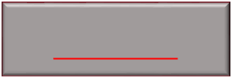

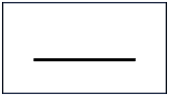



Group Timesheet (TIMEG) or Timesheet Adjustment (TADJ) Entries

Exception Paid
Positive Paid: Primary Assignment
Positive Paid: Additional Classified Assignment
Positive Paid: Additional Certificated Assignment

Regular Hours | NO Entry | REG | REG | REG
Additional Hours: Not  Extra Duty for Scheduled | DAYOT | DAYOT | DAYOT | DAYOT
Workdays
Additional Hours: Not
Extra Duty for | WKOT | WKOT | WKOT | WKOT
Unscheduled Workdays

Leave Usage
NEVER USE REG
Correct Leave Usage Code
Correct Leave Usage Code
DO NOT USE
DO NOT USE


Extra Duty Assignments for Certificated Assignments
Option 1: A Descriptive Pay Event Code on the Primary Assignment

Option 2: A Descriptive Pay Event on an Extra Duty Assignment
Descriptive Pay Event Code Examples

HCM Pay Event Code | Short Description | Long Description
BAND | BAND DOL EPP | BAND Dollar paid as earned
BANDT | BAND T EPP | BAND Time paid as earned
CEP | CERT XTRA T PRD | Certificated Extra Period Time paid as earned
CEPD | CERT XTRA D PRD | Certificated Extra Period Dollar paid as earned
CEPDN | CERT XTRA D NPP | Certificated Extra Period Dollar not paid as earned
CEPN | CERT XTRA T NPP | Certificated Extra Period paid as earned
CLBN | CLBN DOLL NPP | Club Advisor Dollars not paid as earned
CLBNT | CLBN TIM NPP | Club Advisor Time not paid as earned
CLUBD | CLB ACT DOL EPP | Club Activities Dollars Paid as Earned
LDMNT | LEDM TIM NPP | Lead Mentor Induction Time not paid as earned
LDTMN | LDTM NPP | Leadership Team Member Dollars not paid as earned
LDTNT | LEAD T TIM NPP | Lead Teacher Time not paid as earned
MNTNP | MENTOR PAY NPP | Mentor Teacher Pay - not paid as earned
SATSC | SAT SCH T PE | Saturday School Time paid as earned
TUT | TUT DOLL EPP | Tutorial Dollars paid as earned
TUTRD | EXPY TUTR D | Extra Pay for All Tutoring Dollar
TUTT | TUT TIME EPP | Tutorial Time paid as earned
YRBKD | YEARBOOK D | Year book: All duties/activities Dollar
YRBKT | YEARBOOK T | Year book: All duties/activities Time

Classified Additional Assignments: NO Extra
Duty Titles or Assignments in HCM






Primary Assignment: Additional Hours using DAYOT or WKOT

Secondary Assignments
(Jobs): Use REG time

Titles (Job Classifications) must be descriptive of the job duties being performed

REG Pay Rates MUST be on a published salary schedule

This process meets CalPERS Reporting Requirements




Leave With and Without Pay Scenarios:

Step 3: Complete the Group Timesheet (TIMEG) or Timesheet Adjustment (TADJ) to record Half Pay

Step 4: Complete the Employee Status Maintenance (ESMT) for the Leave without Pay
Leave With or Without Pay | Exception or Positive Pay | HCM Pay Event Code | Short Description | Long Description
Leave With Pay | Exception and Positive Paid | LOAPY | PAID LEAVE | Leave of Absence - Paid
Leave With Pay | Exception and Positive Paid | HFPY0 | HALF PAY EX | Half Pay - Exception
Leave With Pay | Exception and Positive Paid | HF50P | HALF PAY | Half Pay
Leave Without Pay | Exception and Positive Paid | AWOP | ABSENT WO PAY | Absent With Out Pay
Leave Without Pay | Exception and Positive Paid | LOAUP | UNPAID LEAVE | Leave of Absence - Unpaid

Pay Event Codes






Scenario 1: Leave with Pay to Leave With 50% Pay to Leave Without Pay
Scenario 2: Leave without Pay that does not transition from Leave with Pay to Leave without Pay

Scenario 3: Leave With Pay only

Scenario 4: Leave Without Pay for
less than one full working day

Step 1: Complete the Employee Status Maintenance (ESMT) for the Leave with Pay

Step 1: Complete the Employee Status Maintenance (ESMT) for the Leave without Pay

Step 1: Complete the Employee Status Maintenance (ESMT) for the Leave with Pay

Step 1: Complete the Group Timesheet (TIMEG) or Timesheet Adjustment (TADJ) to record Docked Pay

Step 2: Complete the Group Timesheet (TIMEG) or Timesheet Adjustment (TADJ) to record leave usage
HCM Pay Event Codes




Working Out of Class Scenarios and
Payroll: NO ACTION Needed
Payroll: NO ACTION Needed

Payroll: ACTION Needed
Payroll
- W orking Out of Class is when an employee will be assuming part or all of the job duties of an employee who is in a higher-level appointment
- The employee’s pay would increase to reflect at least a 5% increase in Gross Pay.








- The employee’s working out of class duties must also be accurately reported as creditable for CalSTRS or CalPERS
100% Backfill for at least 1 full working day
Example1: An employee is on leave that need to be backfilled until they return from leave

Example 2: An employee has terminated, and the position needs to be backfilled until a replacement has been identified
Partial Backfill for at least 1 full working day
Example 1: An employee is on leave and needs to have some of their job duties assumed by another employee

Example 2: An employee has terminated and need to have some of their duties assumed by another employee
Backfilling for a time period that does not require a change in employee appointment
Example 1: An employee is absent for part of a working day and their job duties will be completed by another employee

Example 2: An employee is absent for an entire working day but does not need an employee appointment change. It will be recorded on either a Group Timesheet (TIMEG) or a Timesheet Adjustment (TADJ)




Working Out of Class: Backfilling for a time period that does
Step 1: Mary’s Group Timesheet (TIMEG) or Timesheet Adjustment (TADJ) is completed
Attendance and Leave Management
(ATLM) Activity Folder
Time is recorded on the TIMEG or TADJ document for the specific pay event for backfilling.
The rate of pay would be at least 5% more than the employee’s current pay rate for regular work hours
HCM Pay Event Codes
not require a change in employee appointment

Backfill for less than 1 full working day or does not need to be changed at the appointment level

Example A: Joe is going to be out for 3 hours, and Mary will assume his job duties for those 3 hours
Example B: Joe is going to be out for 1 ½ days and Mary will assume his job duties for that time.

Backfilling for a position that does not impact the employee appointment | Employee Profile Management (EPM) Documents | Position Control Authorization Impact (PAMT)
Step 1: Complete the Group Timesheet (TIMEG) or the Timesheet Adjustment (TADJ) to record the time worked supporting the backfill activities | Not Applicable: there would not be any changes to appointment of the employee who is completing duties that in addition to their regular primary appointment | Not Applicable: there would not be any changes to appointment of the employee who is completing so their would be any changes to the Incumbent and FTEs
- The employee’s gross pay will increase to reflect the time spent supporting the backfill job duties
- The employee’s creditable time for CalSTRS or CalPERS reporting will reflect the backfill activities

Working Out of Class (Temporary  Upgrade) | HCM Pay  Event Code | Short Description | Long Description
100% Temporary Upgrade | TUPP | TEMP UP 100 PER | Temporary Upgrade Pay - 100 Percent Duties - Percent Based
Less than 100% Temporary Upgrade | TULP | TMP LES 100 PER | Temp Upgrade Pay - less than 100 Percent Duties - Percent

Stipends in HCM

Paid Every Pay Period: Percent Based
Entered as a Pay Parameter on the Employee Status Maintenance (ESMT) by the HR Team.



Will pay only when REG time is entered for the employee Scenario 1: Employee works 10 months and is paid for 10 months
Scenario 2: Employee works 10 months and is paid for 11 or 12 months. Stipend only paid for 10 months

Paid Every Pay Period: Dollar Based
Entered as a Pay Parameter on the Employee Status Maintenance (ESMT) by the HR Team. Will be paid regardless as long as they are in an active pay status.



Not Paid Every Pay Period: Hours Based

Entered on a Timesheet Adjustment (TADJ) by Payroll Team

Not Paid Every Pay Period: Dollars Based

Entered on a Timesheet Adjustment (TADJ) by Payroll Team
25

Other HRS Activities – What do you do?



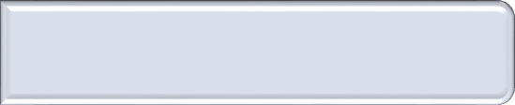

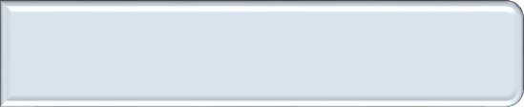



Time Report Overrides?
- Override Pay Rates
- Other Examples?

Pay on Different Pay Cycles
- Pay on a pay cycle different that the one on the HRS Job
- Other examples?

Pay Extra Hours on Different Pay Cycles
- Pay Extra Hours on a Pay Cycle that is different than the HRS Job they were worked against
- Other examples?

Other Pay Activities

  - Other Examples?

HCM Preliminary Payrolls and Payroll Processing

Regular Payroll Process in HCM
Regular Payroll Production
Bank File & Check Generation
Sent out after Payroll completes, processed by bank and/or printed & distributed
Issue Date
Payroll Accounting
Vendor Payments
The check date (funds available)
Retirement Reporting

Time to Gross
Preliminary Payroll
Processing of Time Documents
A preview of what payroll will look like

Actual Payroll Production Date (usually 3 days before check date)


HCM Payroll Processing
Time to Gross
Processing of Time Report Documents
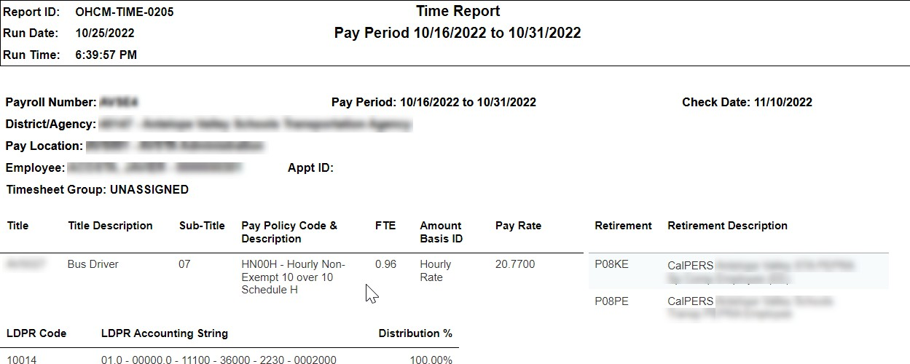
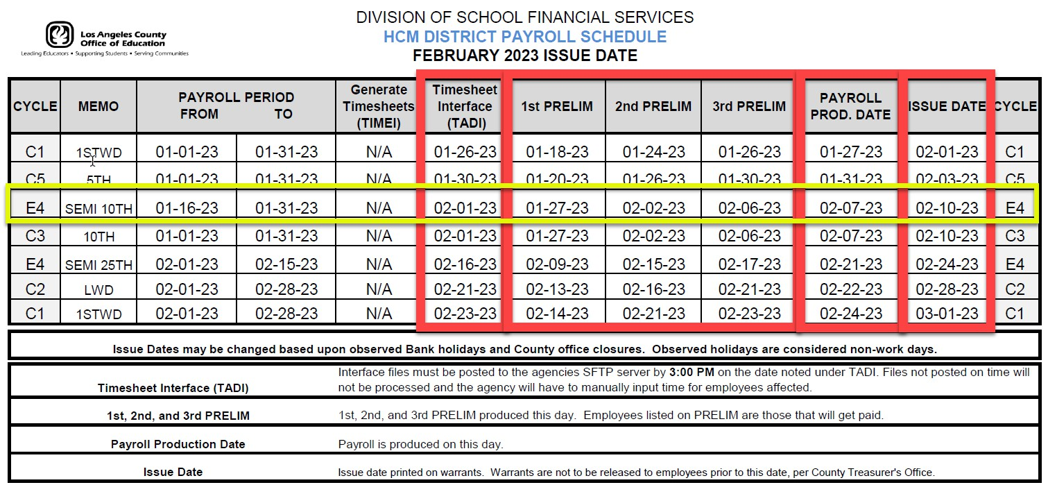






HCM Payroll Processing

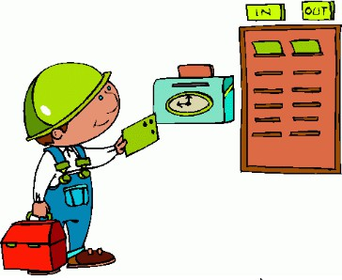
Time to Gross Preliminary Payroll

Processing of Time Report Documents
A preview of what payroll will
look like

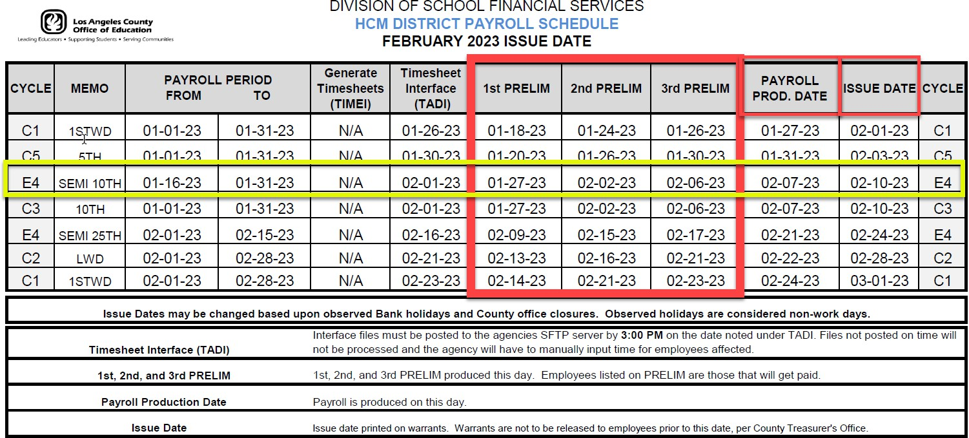
-Same as Verification Process in HRS and RAD
-Preliminary Payroll Registers run three (3) times before final payroll (new functionality)
-A Prelim Error Gross-to-net Report is also scheduled and run
-Preliminary Registers are used for review your payroll information and data



HCM Payroll Processing

Time to Gross Preliminary Payroll

Processing of Time Report Documents
A preview of what payroll will
look like

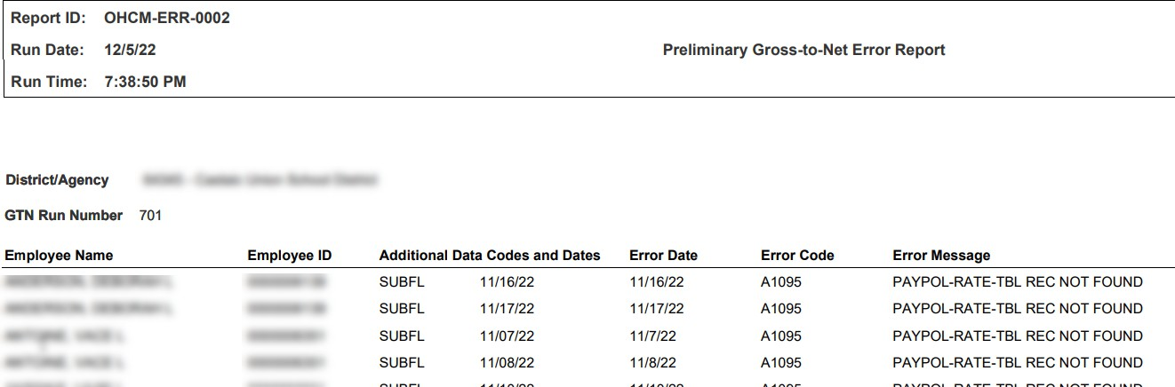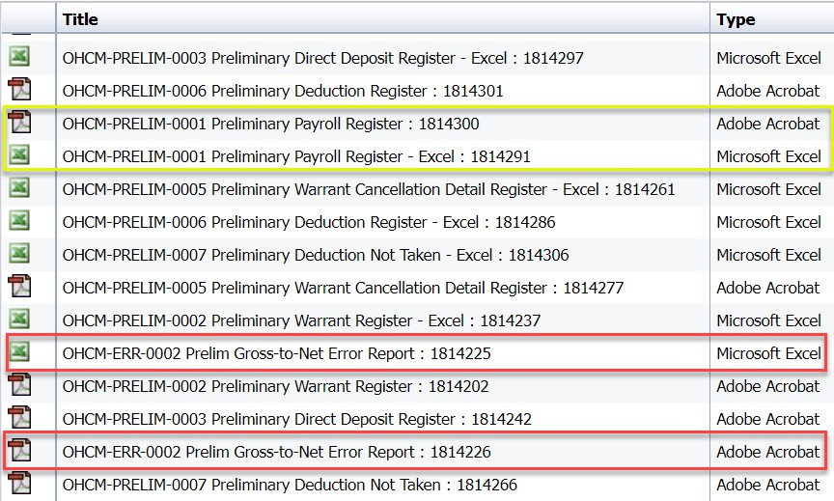

Preliminary Payroll Reports












First Preliminary Payroll Report Review and Corrections
Second Preliminary Payroll Report Review and Corrections
Third Preliminary Payroll Report Review and Corrections
Preliminary Payroll Reports
Preliminary Payroll Reports
Preliminary Payroll Reports
Gross-to-Net Error Report
Gross-to-Net Error Report
Gross-to-Net Error Report
Preliminary Payroll Register
Preliminary Payroll Register
Preliminary Payroll Register
Pending Pay
Pending Pay
Pending Pay
Pending Deduction
Pending Deduction
Pending Deduction

Time Entry in HCM or Time Information from 3rd Party System

OCHM-ERR-0002 Prelim Gross-to-Net Error

- The prelim gross-to-net report is automatically placed in your scheduled reports folder on a daily basis. This is an error report that captures errors generated during payroll cycles by employee.

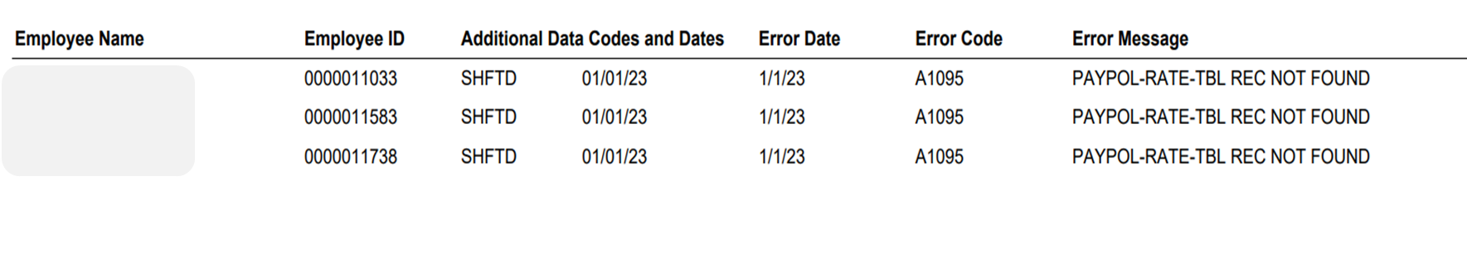

OCHM-PRELIM-0001 Preliminary Payroll Register

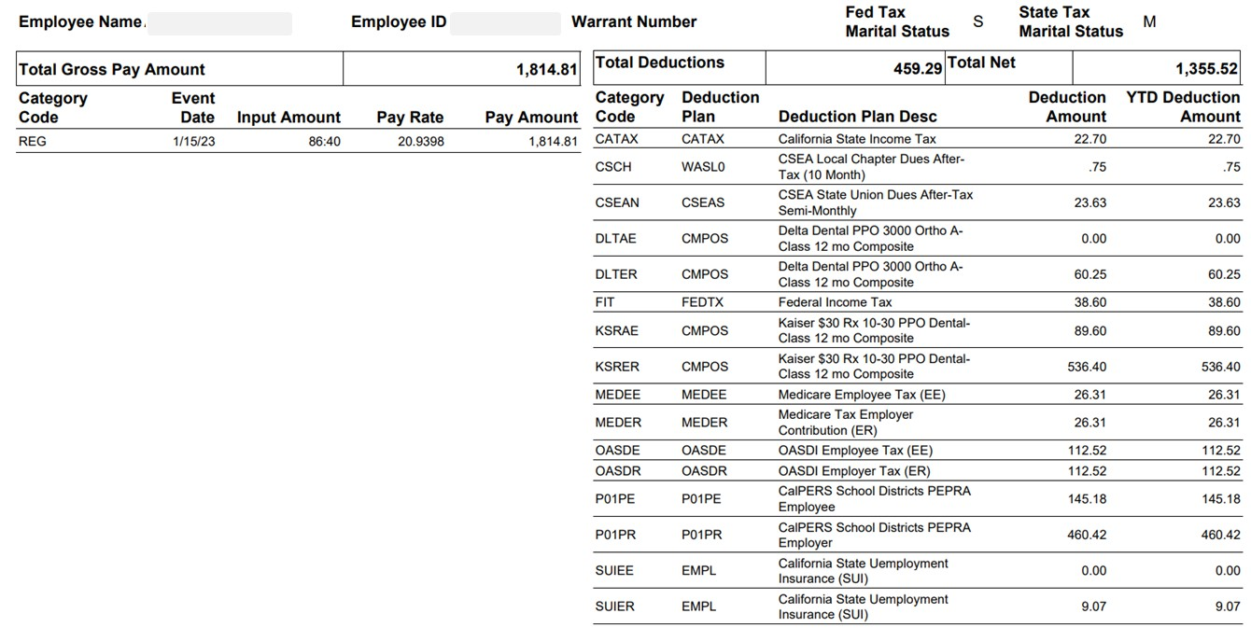
- The preliminary payroll register is automatically placed in your scheduled reports folder on a daily basis. This report comes in the form of a PDF or excel. The Payroll Register report lists all employees who were paid during a specified pay cycle. For each employee the report lists all data appearing on the employee's pay check stub. The employees are grouped by pay cycle, payroll group, payroll number, and bank account number. The report prompts the user for the GTN Run Number. You can also run this report manually. Data on the report is reset after every preliminary date referenced in your payroll calendar.

OHCM-PAYR-0087 Pending Pay

  - The pending payment report is a report that can be manually generated at any time. This report can be found in the payroll folder. You can filter down the report by a number of criteria to review including payroll number, event date, employee, and/or document code. The system shall provide the ability to track all pending pay for each assignment or person in every pay period.

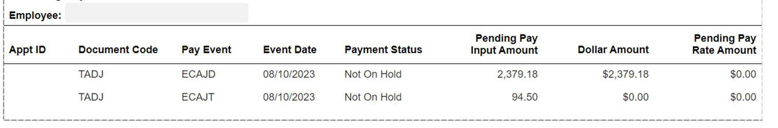

OHCM-DEDS-0224 Pending Deduction

- The pending deduction report is a report that can be manually generated at any time. This report can be found in the benefits and deductions folder. The Pending Deductions Report shows pending deductions displayed from the Deduction Management Activity Folder. Entries are listed by Deduction Type. There are prompts for Employee Status, Deduction Type, and Deduction Code i.e. OTDED, RTRO. Report can be used after retro process has run to verify pending deductions.
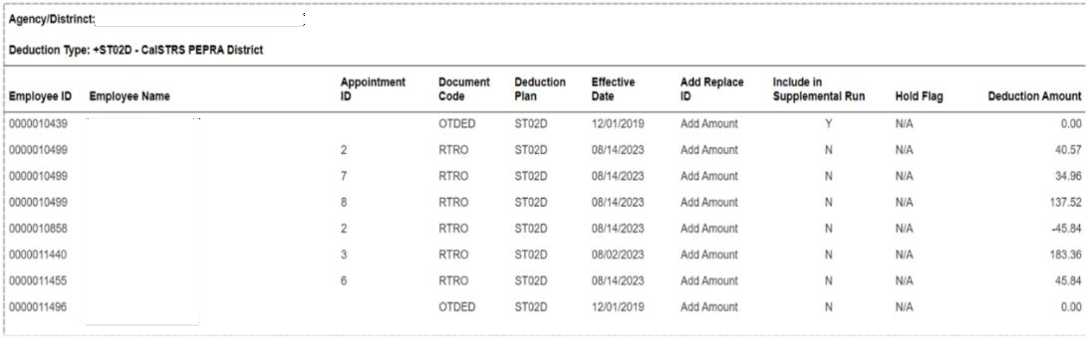

HCM Payroll Processing

Time to Gross Preliminary Payroll

Regular Payroll Production

Processing of Time Report Documents

A preview of what payroll will look like

Actual Payroll Production Date (usually 3 days before check date)








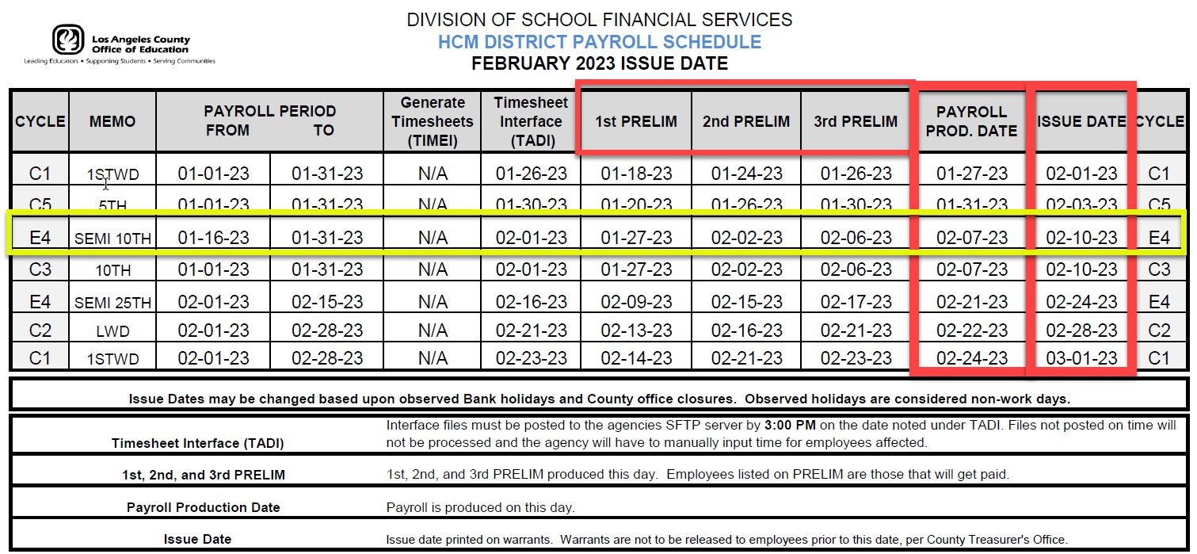

E 37



HCM Payroll Processing

Time to Gross

Preliminary Payroll

Regular Payroll Production

Processing of Time Report Documents

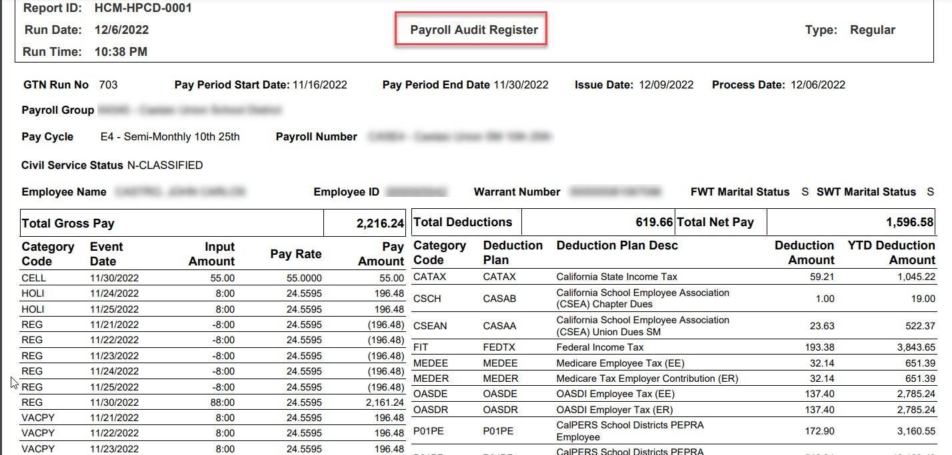
A preview of what payroll will look like

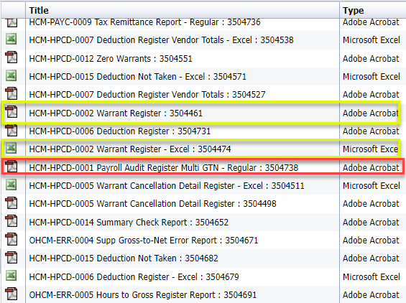
Actual Payroll Production Date (usually 3 days before check date)

OHCM-ERR-0001 Regular Gross-to-Net Error Report

- The regular gross-to-net report is automatically placed in your scheduled reports folder the day after payroll production day. This is an error report that captures errors generated during payroll cycles by employee.
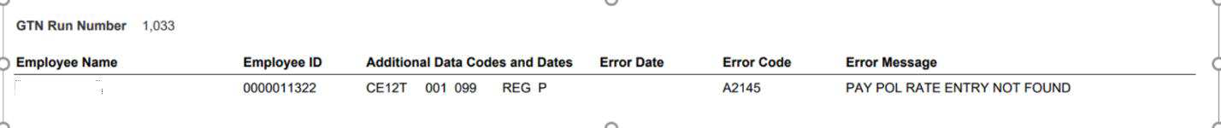

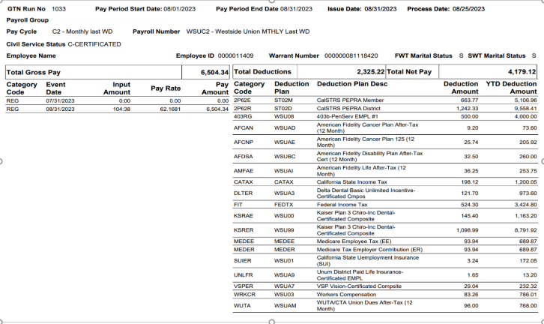
HCM-HPCD-0001 Payroll Audit Register

  - The Payroll Audit Register report is automatically placed in your scheduled reports folder the day after payroll production day. The Payroll Register report lists all employees who were paid during a specified pay cycle. For each employee, the report lists all data appearing on the employee's paycheck stub. The employees are grouped by pay cycle, payroll group, payroll number, and bank account number. The report prompts the user for the GTN Run Number.

HCM-PAYC-0009 Tax Remittance Report

- The HCM-PAYC-0009 report is a report to run after each payroll. The report is in the tax reporting folder. You will need the GTN number of the payroll you would like the report for. The Tax Remittance Report includes Total Gross and Liabilities for Fed, OASDI, Med, Statue, and SUI for payroll by Schedule and District.

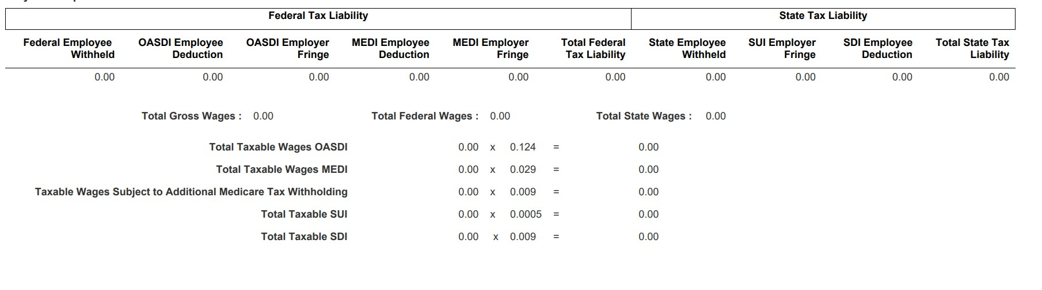

HCM-HPCD-0012 Zero Warrants

- The Zero Warrants report is automatically placed in your scheduled reports folder the day after payroll production day. The Zero Warrants report is a listing of all warrants that have a net amount of 0 or less. The user is prompted for the GTN Run Number, Payroll Group, Employee ID, and Employee Name.
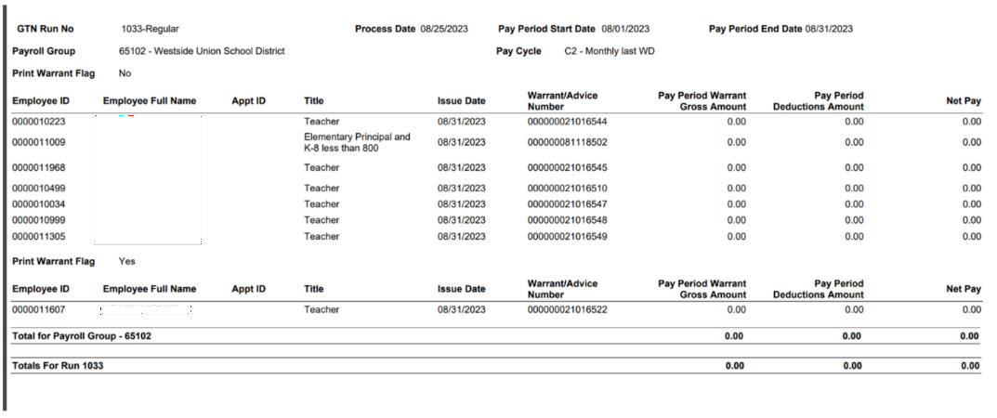

HCM-HPCD-0015 Deductions Not Taken

- The Deductions Not Taken report is automatically placed in your scheduled reports folder the day after payroll production day. The HCM Deduction Register report lists all employees who had deductions that were not taken during a pay period. Consideration should be given for the size of the report if multiple GTN run numbers are used. This report uses the Pay Cycle universe which provides real time data at the time of payroll.
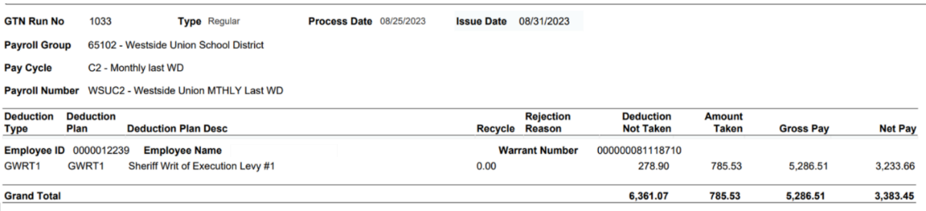

Regular Payroll Process in HCM
Time to Gross
Processing of Time Documents
Preliminary Payroll
Regular Payroll Production
Bank File & Check Generation
Issue Date
Actual Payroll Production Date (usually 3 days before check date)
Sent out after Payroll completes, processed by bank and/or printed & distributed
The check date (funds available)
Retirement Reporting
Payroll Accounting
Vendor Payments

A preview of what payroll will look like

